**Aim:**

To design and deploy a Hospital Management System on a cloud platform (Zoho Creator) using forms for Patient Details, Doctor Details, and Pharmacy Details, thereby demonstrating Software as a Service (SaaS).

**Procedure:**

1. **Login to Zoho Creator**
   * Open Zoho Creator and sign in with your Zoho account.
2. **Create a New Application**
   * Click **Create Application → From Scratch**.
   * Name it: **Hospital Management System**.
3. **Design Forms (Input Screens)**
   * **Patient Details Form**
   * **Doctor Details Form**
   * **Pharmacy Details Form**
4. **Create Reports (Views)**
   * Create a report table for each form: **Patient List, Doctor List, Pharmacy Inventory**.
   * Apply filters to search by Patient Name, Doctor Department, or Medicine Stock.
5. **Add Workflow (Optional)**
   * Use Zoho Deluge scripts to:
     + Send confirmation when a patient is registered.
     + Trigger low-stock alerts when medicines fall below a set quantity.

Doctor Details:

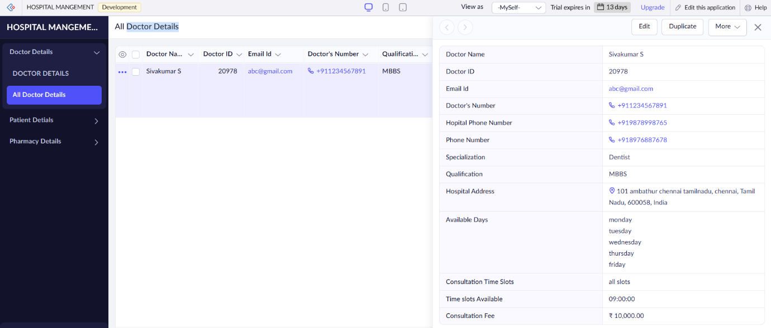

Pharmacy Details:

**Result**

* The Hospital Management System was successfully created and deployed on Zoho Creator.
* Patient details, doctor information, and pharmacy inventory can be stored and managed efficiently.
* Reports allow easy access to patient lists, doctor availability, and medicine stock levels.
* The application runs on Zoho’s cloud platform, accessible globally, thereby demonstrating **Software as a Service (SaaS)**.